**FULLY-CONNECTED TENSOR NETWORK DECOMPOSITION AND ITS APPLICATION TO HIGHER-ORDER COMPLETION**

**PROJECT REPORT**

***Submitted by***

**Kaushik M CB.EN.U4AIE19036**

**Vijai Simmon S CB.EN.U4AIE19068**

**AMRITA SCHOOL OF ENGINEERING,**

**COIMBATORE - 641112**



|  |  |  |
| --- | --- | --- |
| **S.NO** | **TABLE OF CONTENTS** | **PAGE NO.** |
| **1** | **ACKNOWLEDGEMENTS** | **3** |
| **2** | **ABSTRACT** | **4** |
| **3** | **INTRODUCTION TO TENSOR** | **5** |
| **4** | **INTRODUCTION TO TENSOR DECOMPOSITION** | **7** |
| **5** | **DIFFERENT TENSOR DECOMPOSITIONS** | **8** |
| **6** | **DRAWBACKS OF TT AND TR DECOMPOSITION** | **9** |
| **7** | **FCTN-FULLY CONNECTED TENSOR NETWORK DECOMPOSITION** | **10** |
| **8** | **OBJECTIVES OF FCTN** | **11** |
| **9** | **FCTN DECOMPOSITION ANALYTICAL EXPLANATION** | **11** |
| **10** | **PYTHON IMPLEMENTATION FOR TT DECOMPOSITION** | **15** |
| **11** | **ALGORITHM OF TENSOR COMPLETION USING FCTN** | **16** |
| **12** | **MATLAB DEMONSTRATION OF TC USING FCTN** | **17** |
| **13** | **CONCLUSION** | **19** |

# **ACKNOWLEDGEMENTS**

We take this opportunity to extend our gratitude to our project guide, **Dr . K.P Soman** for his unwavering support shown to us during the course of this project. His invaluable guidance and the dedicated zeal he inspired in us helped us a lot.

Furthermore, we wish to thank Centre for Excellence in Computational Engineering and Networking department to give us such opportunity to work in this project.

We also wish to thank Amma for her benevolence which helped us out during the tough times of the projects and helped us persevere and obtain a successful end result.

# **ABSTRACT**

Tensor ring (TR) and tensor train (TT) decompositions have end up with certain results in science. But these two decompositions introduced the connection only between adjacent two factors and also they are highly sensitive to the permutation of tensor models.

But Tensor decomposition introduces the multilinear connections or the connection between the factors by decomposing Nth-order tensor into set of Nth-order factors. It is called as fully connected tensor network (FCTN) because it can be represented graphically as a fully connected network of all factors.

The FCTN decomposition's major feature is its exceptional ability to correctly characterise the intrinsic correlations between any two modes of tensors as well as the necessary invariance for transposition.

# **INTRODUCTION TO TENSOR**

We often express data for machine learning quantitatively. This is done, particularly when referring to neural network data representation, by the use of something known as a tensor. A tensor is a tool for representing data in N dimensions. Tensors are N-dimensional extensions of matrices.

Tensors are more than just a data storage tool in mathematics. Tensors may   
store numeric data as well as specifications of valid linear transformations between tensors. The following are some examples of such transformations or relationships: The dot product and the cross product It can be beneficial from the standpoint of computer science to Consider tensors to be objects in an equation.

A tensor is a mathematical entity of multi-dimensional arrays. The rank or order of a tensor is the number of dimensions of a given tensor. The order N- Tensor is an element of the tensor product of N-vector spaces.

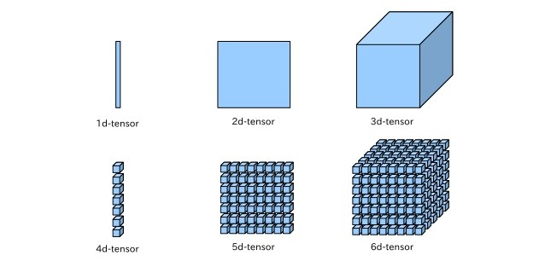

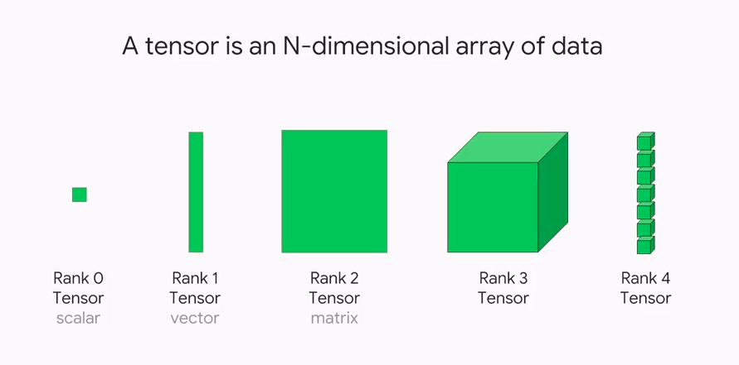

A **zero-rank** tensor is a **scalar**.   
A **1-rank** tensor is a **vector**.   
A **2-rank** tensor is a **matrix**.   
A **3-rank** tensor is a **Tensor**.   
Any **rank** **above 3** are called as **Higher Order Tensors**.

**APPLICATIONS OF TENSORS:**

1. Tensors are used to represent the stress inside a solid or in fluid dynamics in the field of continuum mechanics.
2. In Electromagnetism, we use the Electromagnetic Tensor or in common terms, known as Faraday Tensor.
3. In the field of Quantum mechanics and Quantum computing, the Tensors are used to obtain the combinations of Quantum states.

# **INTRODUCTION TO TENSOR DECOMPOSITION**

Higher-order data, such as multi-temporal, multi-spectral, and multi-scale data, are becoming common as imaging technology advances. These data are typically expressed as higher-order tensors. Tensor decompositions are used to break down a higher-order tensor into a set of low-dimensional factors that describe its latent properties. They have a tremendous ability to record global tensor correlations and have been widely employed in a variety of applications, including signal processing, computer vision, and medical imaging.

More recently, a growing number of tensor network-based tensor decompositions have appeared, demonstrating a strong capacity to cope with higher-order tensors, particularly those exceeding third order. The tensor train (TT) decomposition, which decomposes a Nth-order tensor into N-2 third-order tensors placed at intermediate and two matrices situated on both sides, is one of the most representative among them.

Furthermore, starting with the first TT factor, each factor must do a multi-linear operation with the following factor until the last one is reached (matrix). Tensor ring (TR) decomposition substituted two matrices in TT factors with third-order tensors and constructed an additional multi-linear operation between them as an extension of the TT decomposition.

# **DIFFERENT TENSOR DECOMPOSITION**

**TENSOR TRAIN DECOMPOSITION**

With the tensor network notation, we may envisage a wide range of decompositions. The tensor-train is one of them, which we shall discuss further below. Compression is one of the benefits of encoding a tensor in this tensor-train style. One approach to observe this is to denote d = max(d1, d2,..., dn) and R = max(R1, R2,..., Rn)

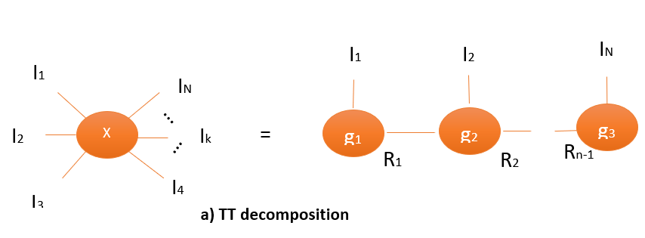

The mathematical notations for Tensor Train Decomposition

IN

Rn-1

TT-format for a tensor A:



This can be written compactly as a matrix product:



Where,

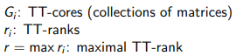

**TENSOR RING DECOMPOSITION**

Tensor-ring decomposition of tensors is important in many applications of tensor network representation in physics and other sciences. The problem of local-minima trapping occurs in the majority of heuristic techniques for tensor-ring decomposition. The minima associated with the correlation's topological structure, in particular, are difficult to escape. As a result, identifying the correlation structure, which is similar to locating matching ends of entangled strings, is a critical effort.

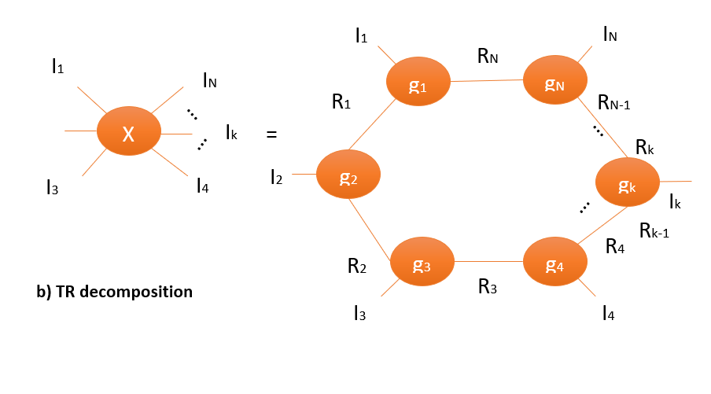

# **DRAWBACKS OF TT & TR DECOMPOSITION**

The TT and TR decompositions, however, have two drawbacks. To begin with, these two decompositions only establish an operation/connection between neighbouring two elements rather than any two components, resulting in a limited characterisation for tensor correlations. Second, TT decomposition preserves invariance only when the target tensor's modes undergo reverse permutation, whereas TR decomposition preserves invariance only when the target tensor's modes undergo circular shifting or reverse permutation.  
These results suggest that these two decompositions are extremely susceptible to tensor mode permutation, resulting in inflexibility in decompositions and applications.

# **FULLY CONNECTED TENSOR NETWORK DECOMPOSITION**

A fully connected tensor network (FCTN) decomposition which decomposes a Nth-order tensor into a set of Nth-order components and establishes a multi-linear operation/connection between any two elements to address two restrictions. The FCTN decomposition offers a superior capacity to directly characterise the intrinsic correlations between any two tensor modes.

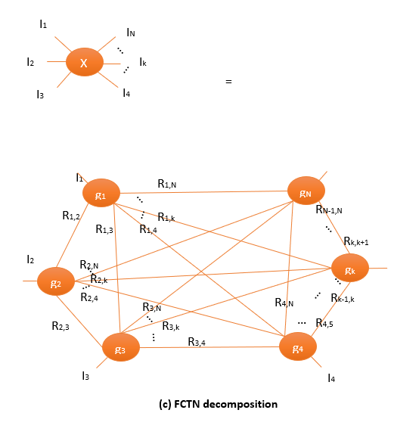

# **THE OBJECTIVES OF FCTN**

1.) In terms of correlation characterization and trans positional invariance, we suggest an FCTN decomposition, which overcomes the restrictions of TT and TR decompositions.

2) To tackle the TC problem, we use the FCTN decomposition and develop an effective proximal alternating minimization (PAM)-based algorithm.

3) the devised algorithm is theoretically convergent by demonstrating that the sequence acquired by it globally converges to a critical point (local minima).

# **FCTN DECOMPOSITION-ANALYTICAL EXPLANATION**

**Definition 1:**

An Nth-order tensor is decomposed using the FCTN decomposition.  into a set of factor tensors of Nth order



with k = 1, 2, · · ·, N More precisely, the element-by-element form of the FCTN decomposition is as follows





(1)

It is easy to observe that the FCTN decomposition is actually the matrix factorization for second-order tensors, and the FCTN-rank is indeed the matrix rank. The matrix factorization is represented by the FCTN decomposition, and the matrix rank is represented by the FCTN-rank. Furthermore, any two FCTN factors Gk1 and Gk2 have the same size for higher-order tensors. Rk1,Rk2 mode utilised to carry out tensor contraction, which allows the FCTN decomposition to characterise the intrinsic connections between any two modes are adequate of the tens-of-thousands-of-thousands. This highlights a significant advantage of the FCTN decomposition over the TT and TR decompositions, which merely create a link between two neighbouring variables. As a result, tensor correlations have a limited characterisation. Furthermore, by simply setting the respective modes of factors to 1, the FCTN decomposition can degenerate into the TT and TR decompositions. It is well known that the matrix factorization is essentially invariable under the trans positional condition in the second-order case, i.e.,  . It's only natural. This trait is expected to be extended to higher-order instances.

**Theorem 1 (Trans positional Invariance):**

Assume the following FCTN decomposition for a Nth-order tensor X: Then, the generalised tensor transposition X n of its vector n-based generalised tensor can be written as 

where n = (n1, n2,· · ·, nN ) is a reordering of the vector (1, 2, · · · , N).

Theorem 2 illustrates another essential advantage of the FCTN decomposition as compared with the TT and TR decompositions. More specifically, the FCTN decomposition is essentially invariable, no matter how to permute the modes of the target tensor. But TR decomposition keeps the invariance only when the modes of the target tensor make a circular shifting or a reverse permuting. And TT decomposition keeps the invariance only when the modes of the target tensor make a reverse permuting.

**Theorem 2:** Assuming that Equation (1) may represent a Nth-order tensor X, the following condition holds:

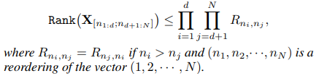

Because the FCTN decomposition seeks to characterise the inherent correlations between any two modes by connecting any two factors, the factors must be built as Nth-order tensors. As a result, storage costs will definitely rise as compared to TT and TR decompositions. In the case of a Nth-order  When FCTN-ranks have the same R1 value, the FCTN decomposition is required  parameters to express it. It appears to be of the same order of magnitude as the Tucker decomposition  parameters). However, when we represent real-world data, the needed FCTN rank R1 is frequently much lower than the Tucker rank R2, since the FCTN decomposition employs  to bound Tucker rank R2.

**Definition 2(FCTN Composition)**

We call the process of generating X by its FCTN factors Gk (k = 1, 2, · · · N) as the FCTN composition, which is also denotes as .

Furthermore, if one of the factors Gt (t ∈ {1, 2, · · · , N}) does not participate in the composition, we denote it as , We obtain that:

**Theorem 3:** Supposing that X= and Mt =  We obtain 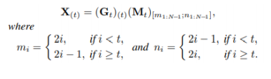

Theorem 4 demonstrates the connection between one FCTN factor and the composition of the other factors. It is critical to the computation of the FCTN decomposition since fixing one element frequently necessitates fixing the others.

# **PYTHON IMPLEMENTATION OF TENSOR TRAIN DECOMPOSITION**

# **ALGORITHM OF TENSOR COMPLETION USING FCTN**



# **MATLAB DEMONSTRATION OF TENSOR COMPLETION USING FULLY CONNECTED TENSOR NETWORK DECOMPOSITION**

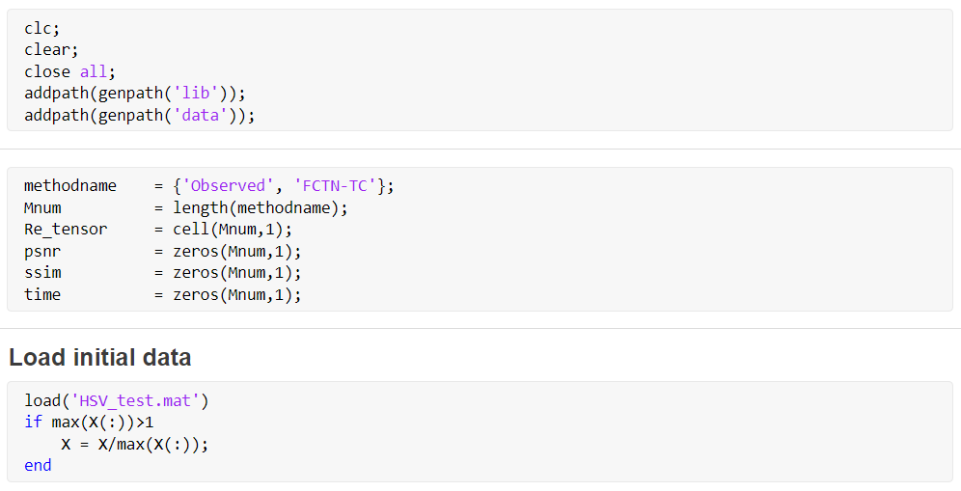

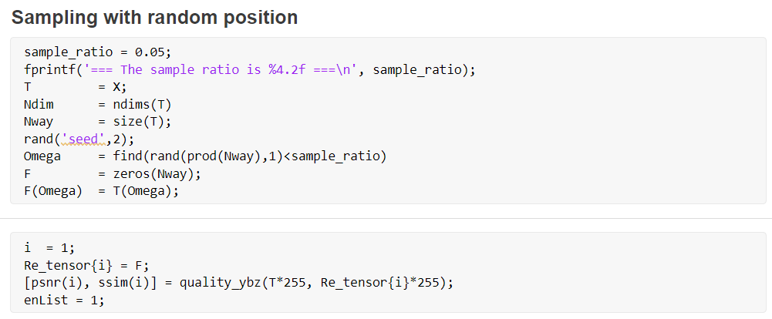

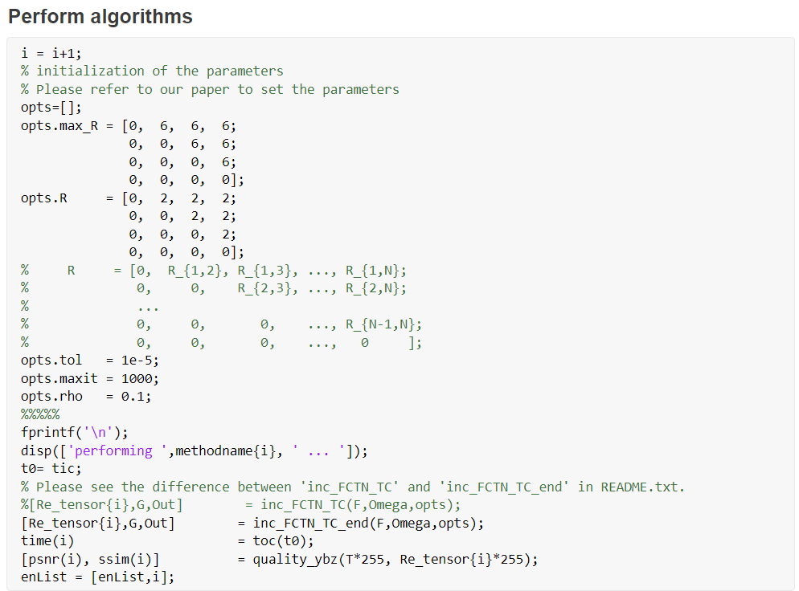 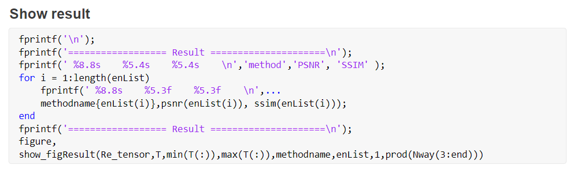**OUTPUT:** 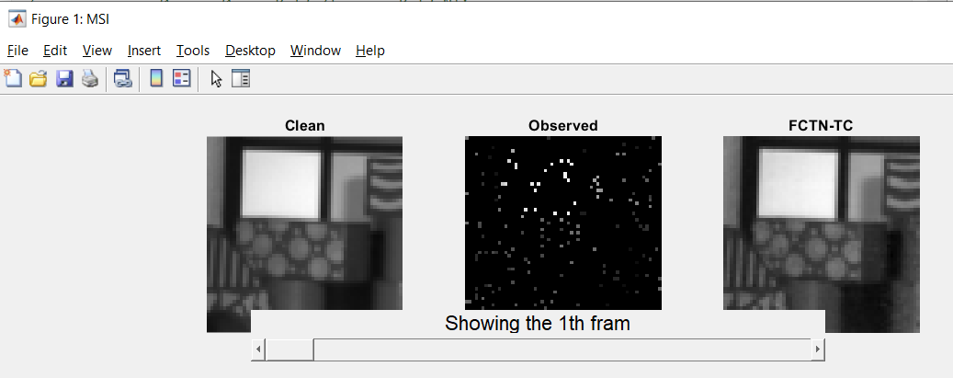

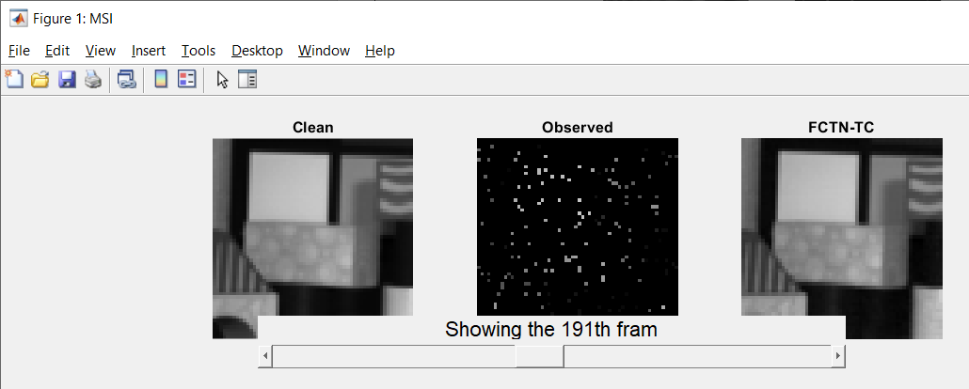

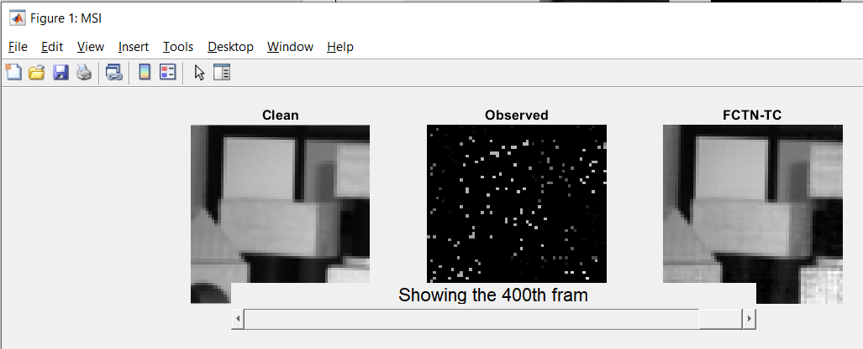

# **CONCLUSION**

The FCTN decomposition is a method for factorising a Nth-order tensor into a set of Nth-order components with complete connections. The FCTN decomposition demonstrated its exceptional capacity to accurately define the correlations between any two modes of tensors and was demonstrated to be fundamentally transpositional invariant The results of the experiments indicated that the FCTN-TC approach produced a better overall result.